Poultry Environment Monitoring System

Report

Experiential Learning/Case Study/ Course Project

GROUP-7

**NAME**  **EMAIL REGD. NO**  **CONTACT.NOROLL.NO**

|  |  |  |
| --- | --- | --- |
| **BIBHU PRASHA NAYAK** [**2101020291@cgu-odisha.ac.in**](mailto:2101020291@cgu-odisha.ac.in) **2101020291**  **RANA SUJEET KUMAR 2101020306@cgu-odisha.ac.in 2101020306**  **SIBOM SAHU 2101020307@cgu-odisha.ac.in 2101020307** | **6371915661**  **6203370346**  **8917684148** | **CIT21091**  **CIT21066**  **CIT21067** |

Guided by:

**Dr. Prasant Kumar Dash**

**Asst. Prof., Dept. of CSE,CGU,ODISHA.**



**Department of Computer Science and Engineering**

**C.V. Raman Global University, Bhubaneswar**

**Odisha, 752054, India**

**Table of Contents**

1. **Problem Statement 1**
2. **Introduction 2**
   1. **Background 2**
   2. **Challenges 3**
3. **Related Work 4**
   1. **Case Study - I 4**
   2. **Case Study - II 5**
   3. **Case Study - III 6**
   4. **Case Study - IV 7**
   5. **Case Study – V 8**
   6. **Case Study – VI 9**
4. **Proposed Work 10**
   1. **Introduction 11**
   2. **Objective 12**
   3. **Challenges 13**
   4. **Proposed Proposal 14**
   5. **Implementation Idea 15**
5. **Conclusion 15**
6. **References 16**

**Problem Statement**

We may condense the shared difficulties and goals into a single problem statement by going over the problem statements from the four research publications on IoT-based smart poultry farm management.

The manual monitoring and control procedures that afflict traditional poultry farming methods result in inefficiencies, higher labor costs, and less than ideal conditions for the productivity and health of the birds. Important difficulties consist of:

1. Inefficient management techniques as a result of physical labor-intensive environmental, cleaning, and feeding duties.

2. The challenge of preserving ideal environmental factors—such as temperature, humidity, and lighting—that are vital to the health of chickens.

3. Hazards related to insufficient observation of variables such as ammonia concentrations and power disruptions.

4. Limited capacity for remote monitoring and automation, which makes it difficult to make decisions in real time .The main problems are summarized in this problem statement.

**II. Introduction**

a. Background

Poultry farming, an integral component of the global agricultural landscape, has undergone remarkable growth in recent decades, fueled by advancements in farming techniques and heightened consumer demand for safe and nutritious food products. Chicken, being the most consumed protein source worldwide, holds a prominent position in the food industry, lauded for its nutrient-rich profile comprising high protein content, coupled with low fat and cholesterol levels.

In tandem with the evolution of agricultural practices, automation has emerged as a transformative force, reshaping traditional farming methodologies across various sectors. Within the realm of poultry farming, the integration of wireless sensor networks (WSN) and mobile communication systems, underpinned by Internet of Things (IoT) technology, offers a paradigm shift towards more efficient and sustainable farm management practices.

The proposed automation solution not only promises cost savings but also prioritizes asset preservation and quality assurance. By leveraging IoT-enabled sensor modules connected to Arduino Uno microcontrollers, essential environmental parameters critical for poultry health and productivity, including humidity, temperature, light, and ammonia gas levels, can be meticulously monitored and controlled in real-time. Moreover, routine tasks such as feeding, water supply, and sanitation are seamlessly managed through automated systems, thereby reducing reliance on manual labor and streamlining farm operations.

Furthermore, the implementation of a web-based monitoring system enables remote oversight and management of poultry farms, empowering stakeholders to make informed decisions and optimize farm performance. This integration of digital technologies not only enhances operational efficiency but also fosters greater transparency and traceability throughout the poultry supply chain, bolstering consumer confidence in product quality and safety.

b. Challenges

Despite the promise of automation, poultry farming grapples with a myriad of challenges, ranging from labor-intensive farming practices to environmental variability and climate change-induced stressors. Traditional farming methods, characterized by manual oversight and intervention, entail significant labor costs and operational inefficiencies, impeding the industry's potential for growth and innovation.

Moreover, the susceptibility of poultry to fluctuations in environmental conditions, exacerbated by rising global temperatures and climate-related disturbances, poses formidable challenges to farm productivity and animal welfare. Ensuring optimal conditions for poultry health and performance necessitates proactive measures to mitigate risks associated with temperature extremes, humidity fluctuations, and exposure to harmful gases.

In navigating these challenges, the adoption of advanced digital technologies presents a compelling opportunity to revolutionize poultry farming practices, fostering resilience and sustainability in the face of evolving environmental dynamics. However, the widespread adoption of IoT-enabled solutions necessitates overcoming barriers related to infrastructure development, technical expertise, and cost-effectiveness, underscoring the need for collaborative efforts across industry stakeholders to drive innovation and facilitate technology adoption.

In conclusion, this research endeavors to explore the transformative potential of automation in poultry farming, offering insights into the opportunities and challenges associated with the integration of IoT-enabled solutions. By leveraging digital technologies to enhance farm management practices, stakeholders can unlock new avenues for efficiency, productivity, and sustainability, ultimately shaping the future of poultry farming on a global scale.

## 2 Related work

Case study 1-

1. IoT Applications in Agriculture:

The application of Internet of Things (IoT) technology in agriculture has gained significant attention in recent years. IoT systems offer real-time monitoring and control capabilities, enabling farmers to optimize resource utilization, improve crop yields, and enhance livestock management practices. In the context of poultry farming, IoT solutions facilitate the monitoring of environmental parameters such as temperature, humidity, air quality, and feed availability, leading to improved bird health and productivity.

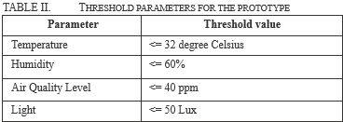

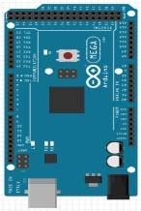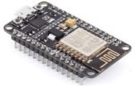

**Photo Resister**

**Servo**

**MQ135**

**Fan**

Relay

**DHT22**

**Fan**

**Relay**

Temperature

and Humidity

Sensor Module

Air Quality

Sensor

Module

Feeder Sensor

Module

Arduino Mega

ESP 8266 MCU

Database

AP

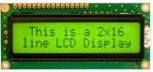

2. Integration of Sensors in Livestock Management:

Sensors play a crucial role in livestock management by providing real-time data on environmental conditions and animal health. Temperature and humidity sensors are commonly deployed in poultry housing facilities to monitor ambient conditions and prevent heat stress or cold stress in birds. Additionally, air quality sensors detect harmful gases such as ammonia, carbon dioxide, and methane, which can adversely affect bird welfare and performance. Feed and water sensors ensure continuous access to essential resources, supporting optimal growth and development in poultry populations.

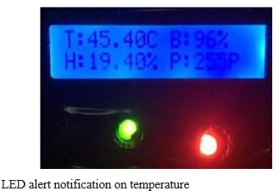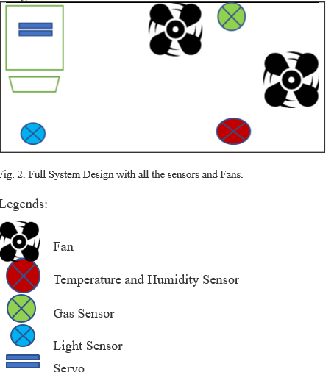

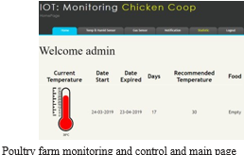

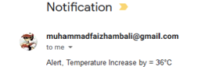

3. Automation and Control Systems in Poultry Farming:

Automation and control systems have become increasingly prevalent in modern poultry farming operations, offering farmers greater efficiency, productivity, and animal welfare. These systems encompass automated feed delivery mechanisms, environmental control systems, and remote monitoring platforms. By automating routine tasks and implementing intelligent control algorithms, poultry farmers can optimize resource utilization, minimize labor costs, and maintain optimal environmental conditions for bird health and performance.

4. Wireless Sensor Networks (WSN) in Agriculture:

Wireless Sensor Networks (WSNs) have emerged as a promising technology for agricultural applications, enabling real-time data monitoring and transmission across large-scale farming operations. In poultry farming, WSNs facilitate remote monitoring of environmental parameters in chicken barns, providing farmers with actionable insights and facilitating timely interventions to mitigate risks and optimize production outcomes. By leveraging WSN technology, poultry farmers can improve operational efficiency, reduce environmental impacts, and enhance overall farm profitability.

5. Previous Work on Smart Poultry Farming Systems:

Several research projects and commercial products have explored the development of smart poultry farming systems, aiming to address key challenges related to environmental monitoring, automation, and control. These systems leverage IoT, WSN, and mobile technology to monitor environmental parameters, automate feeding processes, and optimize ventilation systems in poultry housing facilities. By integrating sensors, actuators, and data analytics tools, smart poultry farming systems offer farmers greater visibility and control over production processes, leading to improved bird health, reduced mortality rates, and increased farm profitability.

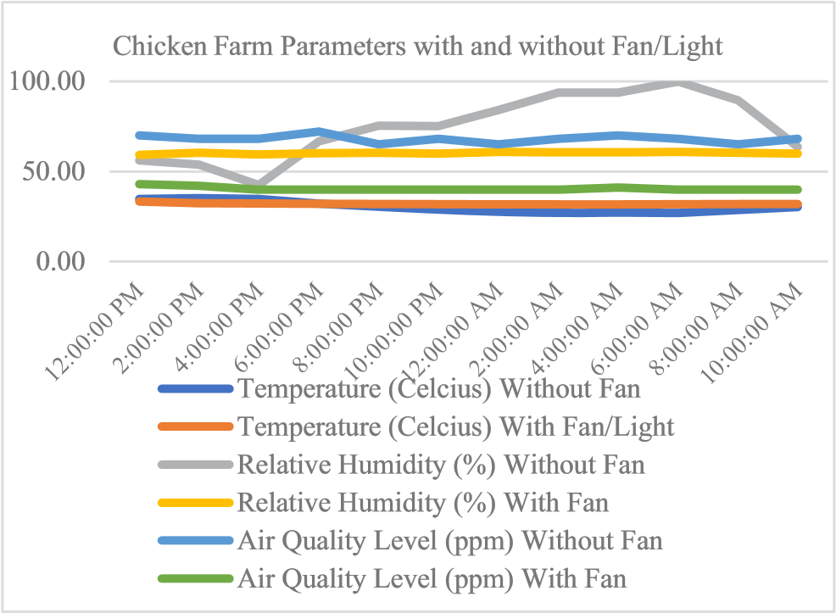

Case study 2-

The related work content in the PDF file "Design and Development of an IoT Based Smart Poultry Farm" focuses on the existing research and developments in the field of IoT applications in poultry farming. Here are some key points from the related work section:

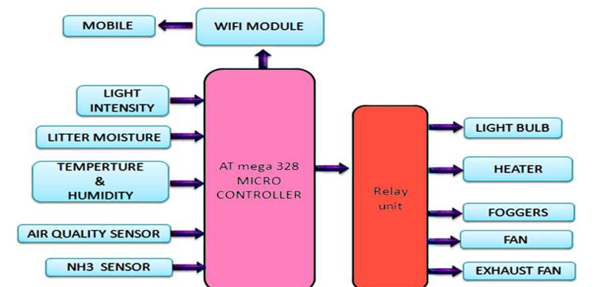

Block diagram

1. The paper discusses the potential of IoT technology in enhancing productivity and reducing costs for poultry farmers [T4].

2. It highlights the importance of creating an effective IoT ecosystem where various objects are interconnected to exchange data and interact with each other [T4].

3. The document emphasizes the significance of maintaining optimal environmental conditions in poultry farms, such as proper ventilation, cooling, and lighting, to ensure the well-being of the birds [T4].

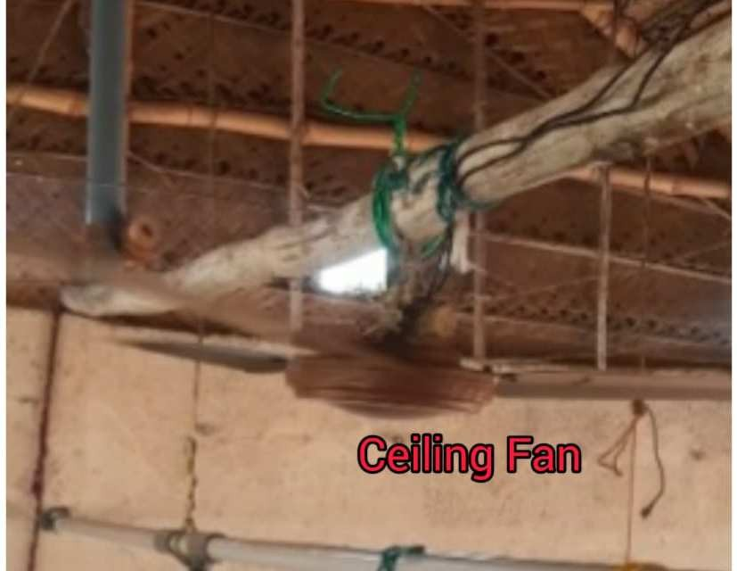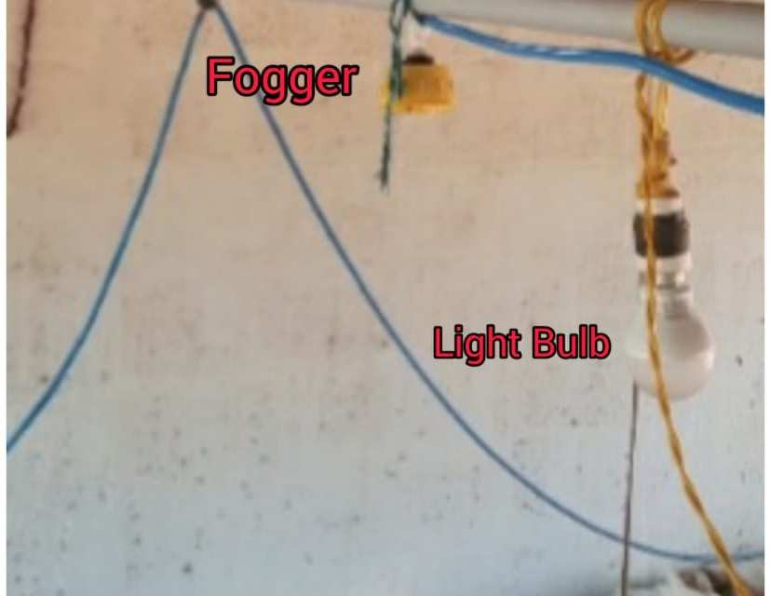

4. It introduces a new paradigm for making traditional chicken farming smarter by utilizing advanced digital technologies, sensors, and microcontrollers [T4].

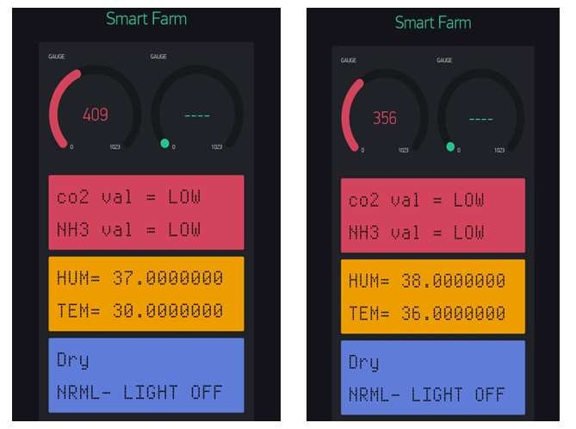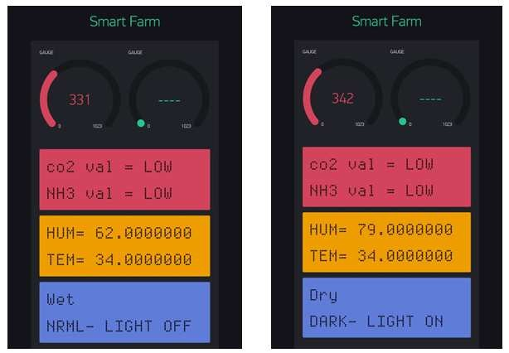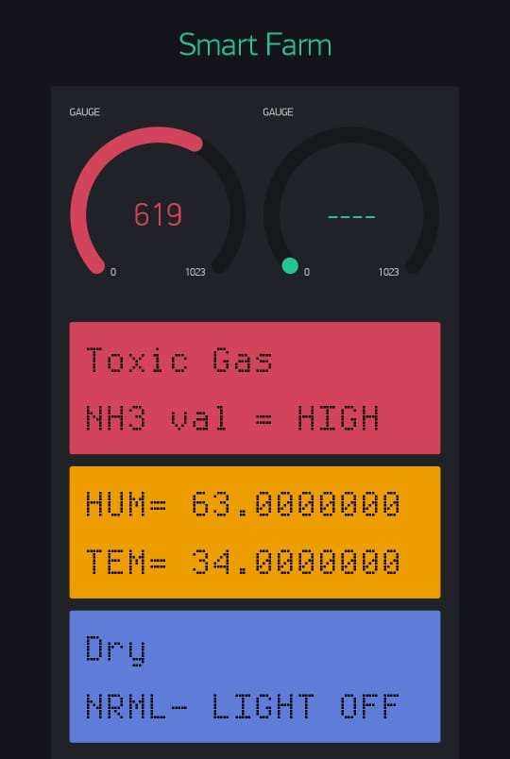5. The related work section underscores the need for automated systems in poultry farming to address challenges efficiently and improve overall productivity [T5].

These points reflect the research and advancements in IoT applications for smart poultry farming, aiming to optimize operations and enhance the well-being of poultry in a cost-effective manner.

Case study 3-

The related work content in the PDF file "IoT Based Smart Automated Poultry Farm Management System" includes references to various research papers and projects that have explored the use of IoT technology in poultry farm management. Here are some key points from the related work section:

1. M. H. Lashari et al. [9] presented an IoT-based poultry environment monitoring system at the 2018 IEEE International Conference on Internet of Things and Intelligence System (IOTAIS). The system focused on monitoring environmental parameters crucial for poultry health.

2. K. A. Sitaram et al. [4] discussed the use of robots in meat poultry farms using IoT technology to monitor factors like temperature, humidity, and gas levels. The system aimed to enhance poultry health and productivity through automated monitoring and control.

3. M. Singh et al. [5] highlighted the integration of IoT in poultry farm monitoring, including video/image processing and sound analysis for bird health assessment. The study emphasized the importance of advanced technologies in improving poultry farm management.

III.

PROPOSED

METHODOLOGY

**Fig.**

**1**

**Block**

**Diagram**

**for**

**Proposed**

**Methodology**

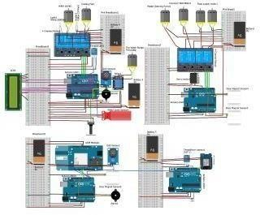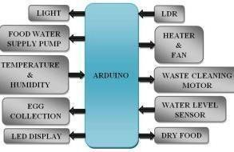

4. Shoba.K et al. [11] proposed an IoT-based system for monitoring and controlling poultry farms remotely. The system utilized wireless sensors to regulate room temperature, monitor chicken weight, and manage food and water supply.

5. M.N. Elham et al. [12] conducted a preliminary study on poultry farm environmental monitoring using IoT and blockchain technology. The integration of blockchain aimed to enhance data security and transparency in poultry farm operations.

6. Zainal H. C. Soh et al. [13] demonstrated the development of an automatic chicken feeder using Arduino Uno, focusing on efficient feeding mechanisms in poultry farms.

7. Adenilson Mumbelli et al. [14] presented a low-cost IoT-based system for monitoring and controlling aviaries, emphasizing remote access through a mobile app for parameter monitoring.

These related works showcase the advancements in IoT technology for poultry farm management, highlighting the importance of automation, remote monitoring, and data-driven decision-making in enhancing poultry health and productivity.

Case study 4-

The related work content of the paper "IoT based Smart Management of Poultry Farm and Electricity Generation" focuses on existing systems and research efforts in the field of smart poultry farming and IoT technology. Here are some key points from the related work section of the paper:

1. Existing System: The paper highlights the use of PIC microcontroller and Raspberry Pi 2 in the existing system for monitoring poultry farm parameters. However, this setup increases costs and complexity. In contrast, the proposed system utilizes Arduino microcontroller, making it simpler and cost-effective.

System Design-

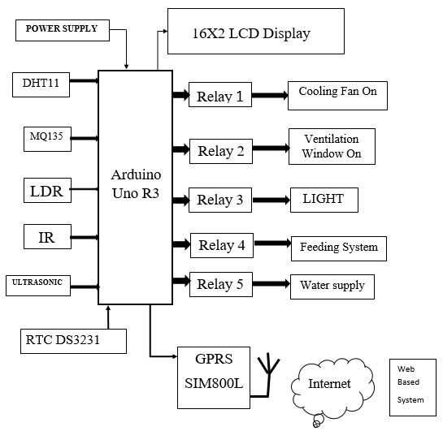

2. Monitoring and Automation: The proposed system aims to monitor various environmental parameters such as temperature, humidity, ammonia gas, and light. It also automates manual tasks like food feeding, water supply, and cleaning chicken waste to reduce manpower and improve chicken health and growth.

3. Communication and Control: In the existing system, data transmission is done using the ESP8266 Wi-Fi module. The proposed system replaces this with a GPRS module for improved communication. Additionally, the system controls ammonia gas levels, temperature, humidity, and water supply using sensors and actuators.

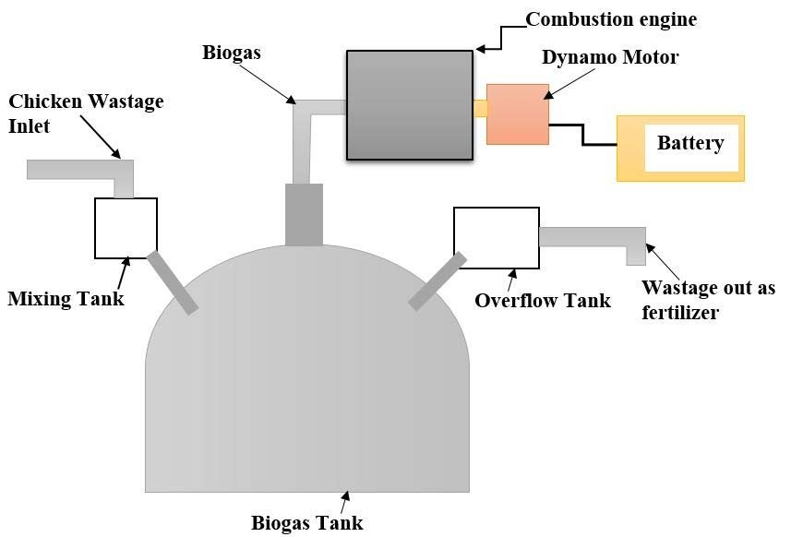

4. Benefits of the Proposed System: The paper emphasizes that the proposed system is cost-effective, improves poultry productivity and health, simplifies farm management, and generates sufficient electricity from chicken waste. It also mentions the development of a website for monitoring farm activities and internal environment.

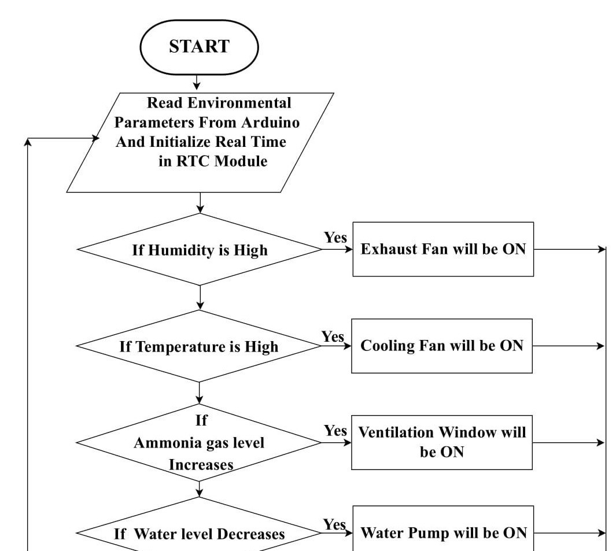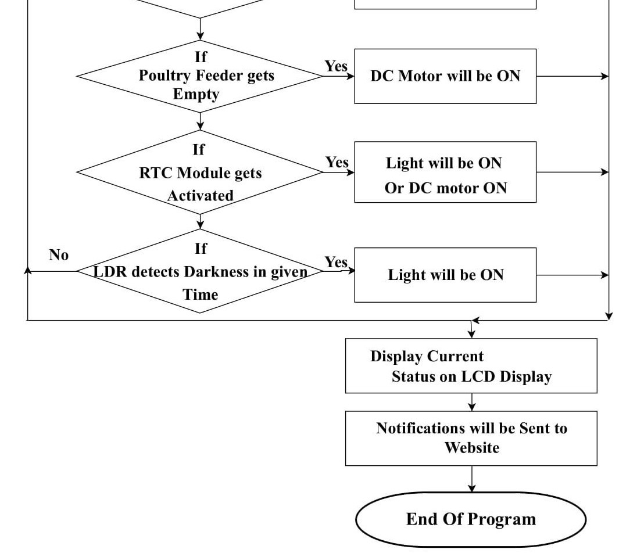

By reviewing the related work section of the paper, it is evident that the proposed IoT-based system offers significant advancements in smart poultry farming by addressing key challenges and enhancing operational efficiency and sustainability.

Case study 5- IOT Based Smart Poultry Farm

1. Monitoring and Controlling Poultry Farms with IoT:

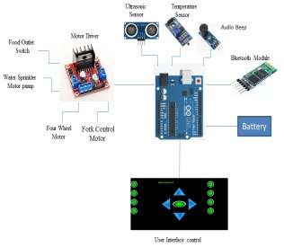

Architecture design

The integration of Internet of Things (IoT) technology in poultry farming has revolutionized the industry by enabling real-time monitoring and control of various parameters. Research has shown that IoT systems can effectively manage environmental factors like temperature, humidity, and gas levels in poultry farms, leading to improved bird health and productivity [1].

2. Automation in Poultry Feeding:

Automatic chicken feeding systems have been developed to alleviate labor-intensive tasks in poultry farms. These systems replace manual feeding processes with automated mechanisms, reducing dependency on human labor and ensuring consistent feeding schedules for the birds. Additionally, automation improves feed efficiency and minimizes food wastage, contributing to overall farm profitability [2].

3. Climate Control in Poultry Housing:

Maintaining optimal environmental conditions is critical for poultry health and productivity. Studies have explored the use of wireless sensor networks (WSNs) to monitor and control climate parameters such as temperature and humidity in poultry housing facilities. Automated climate control systems help regulate indoor conditions, creating a comfortable and conducive environment for bird growth and development [3].

4. Smart Poultry Farming Solutions:

Smart poultry farming solutions leverage emerging technologies like IoT, WSNs, and mobile communication systems to enhance farm management practices. These systems enable remote monitoring and control of poultry operations, providing farmers with real-time insights into environmental conditions and bird welfare. By automating tasks such as feeding, temperature control, and gas reduction, smart farming solutions optimize farm efficiency and productivity [4].

5. Environmental Monitoring and Gas Reduction:

Efforts have been made to develop automated systems for monitoring environmental parameters and reducing harmful gases in poultry farms. Wireless sensor networks are deployed to monitor factors like temperature, humidity, and gas levels, while automated mechanisms such as soil mixtures are used to mitigate gas emissions. These systems help create a healthier and safer environment for poultry, thereby improving overall farm sustainability [5].

6. Wireless Sensor Networks for Poultry Health Monitoring:

Wireless sensor networks play a crucial role in monitoring poultry health and detecting early signs of disease outbreaks. By deploying wireless sensor nodes in poultry farms, farmers can remotely monitor bird health indicators such as body temperature and activity levels. Early detection of health issues allows for prompt intervention, minimizing disease spread and ensuring better flock management [6].

7. Earth-Air Heat Exchangers for Climate Control:

In regions with extreme climate conditions, innovative solutions like earth-air heat exchangers are employed to regulate temperature in poultry houses. These systems utilize natural airflow and underground heat exchange to cool or heat indoor environments, ensuring optimal conditions for bird comfort and welfare. By adopting sustainable climate control technologies, poultry farmers can mitigate temperature extremes and improve production outcomes [7].

Case study 6-

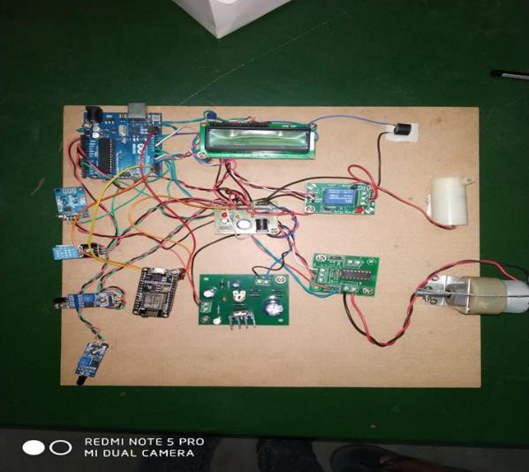

1. Global Architecture of Hybrid Systems for Poultry Sensors:

Research by Chakchai So-In, Sarayut Poolsanguan, and Kanokmon Rujirakul focuses on developing a comprehensive architecture for managing mobile and wireless networks in poultry farms. This system aims to enhance mobility and flexibility by separating electronic and mechanical components, enabling intelligent sensor management for efficient farm operations.

2. Extension of Automation to Farm Level:

Drishti Kanjilal, Divyata Singh, Rakhi Reddy, and Jimmy Mathew's work explores the concept of extending automation to the farm level with the implementation of smart farming techniques. By incorporating automation technologies, such as sensor networks and GSM modules, this research emphasizes the importance of improving efficiency and productivity in poultry farming.

3. Wireless Sensor Systems for Animal Health Monitoring:

H. Okada, H. Nogami, T. Kobayashi, T. Masuda, and T. Itoh have developed wireless sensor systems for continuous monitoring of animal health, focusing on energy-efficient solutions. By employing low-power wireless sensors, this research aims to provide effective health care monitoring while minimizing energy consumption, contributing to improved livestock management practices.

These related works highlight the importance of integrating automation, wireless sensor networks, and communication technologies in poultry farming to enhance efficiency, productivity, and animal welfare. The proposed system in the current research paper builds upon these concepts, offering solutions for automated food and water supply, environmental monitoring, and safety measures in poultry farms.

3 Proposed Model